Dark & Deep Web

Details & How to Access Them

# Surface, Deep & Dark Web

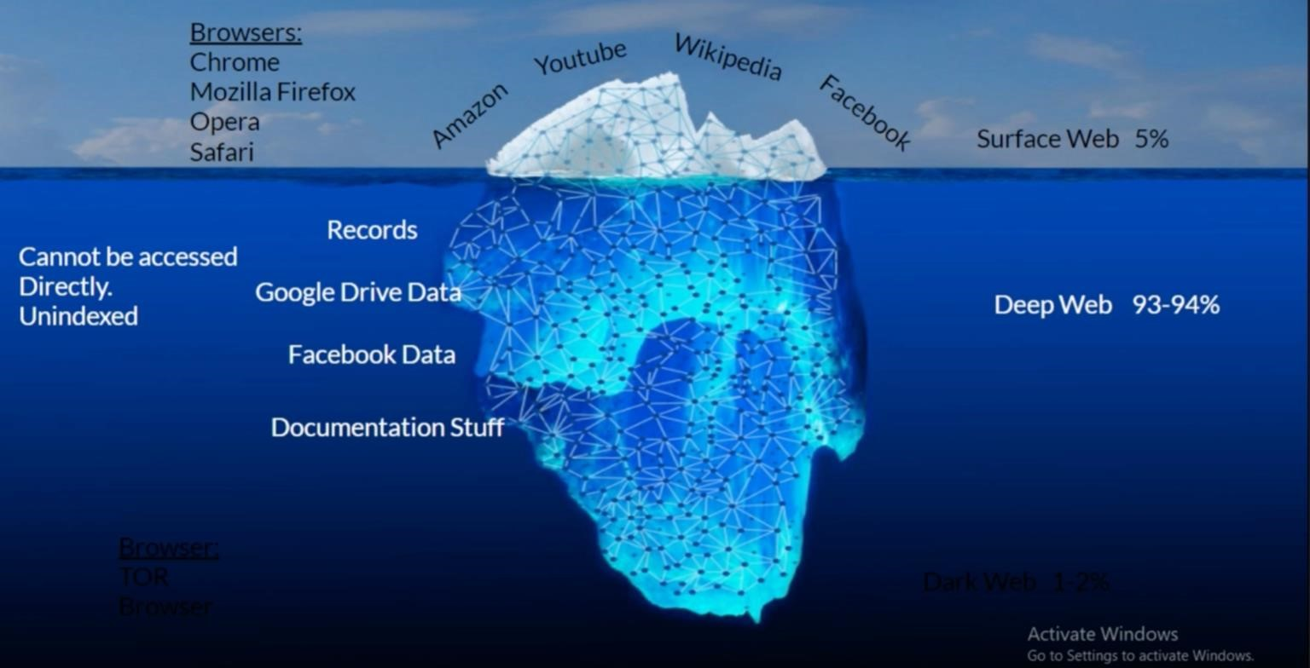

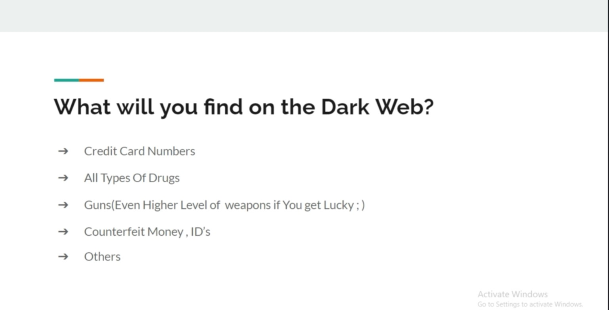

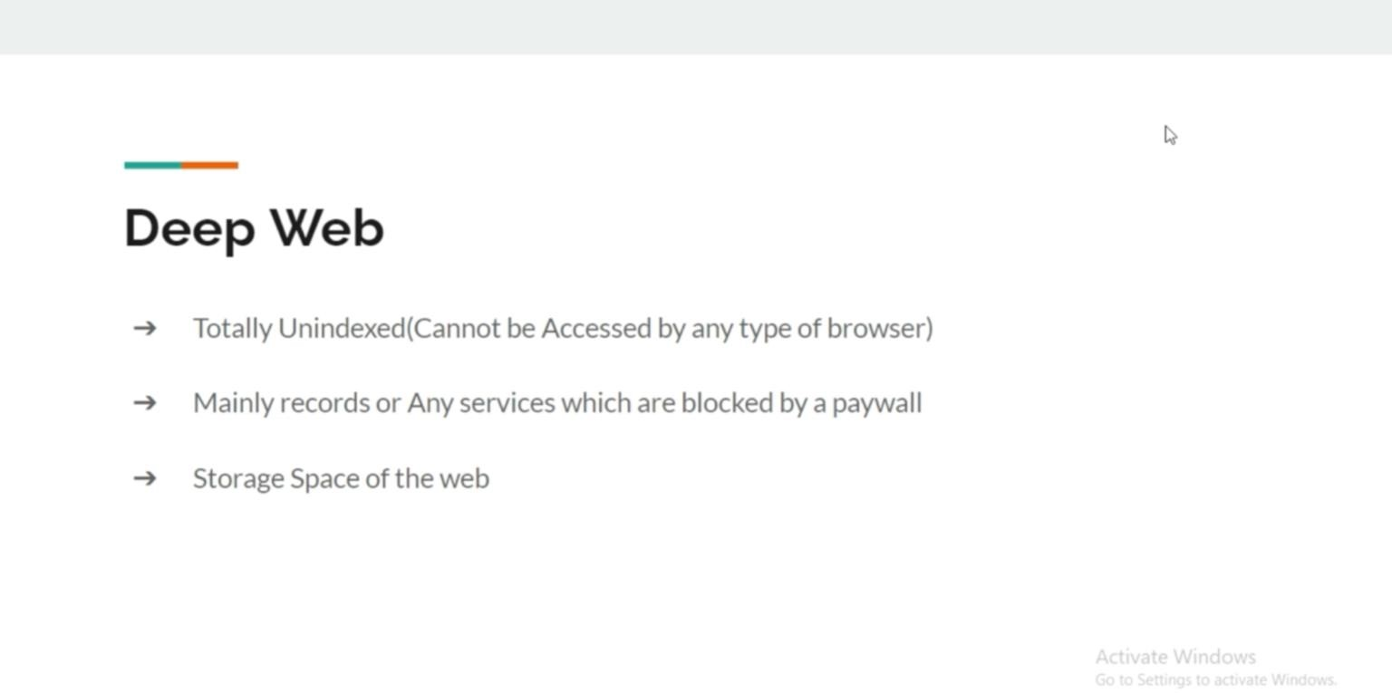

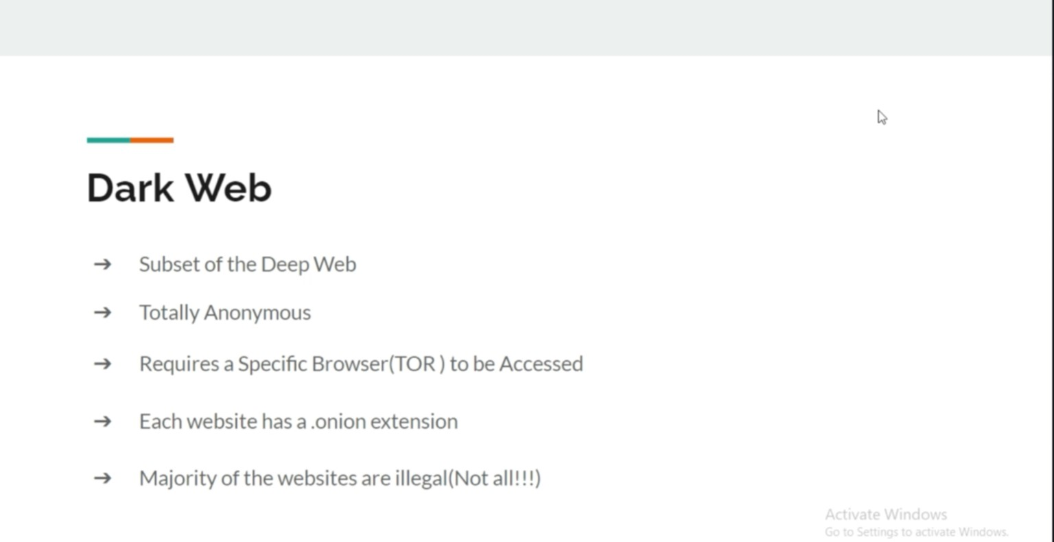

# More To Find

* Illegal drugs
* Hitman
* Child abuse/ sex
* Cheap products like: iPhone, MacBook pro
* Paypal accounts
* Bank cards
* dark web live
* animal abuse video
* hackers
* raptor (links and files)
* stolen data / paypal / credit card
* human products
* buy guns/ grenades

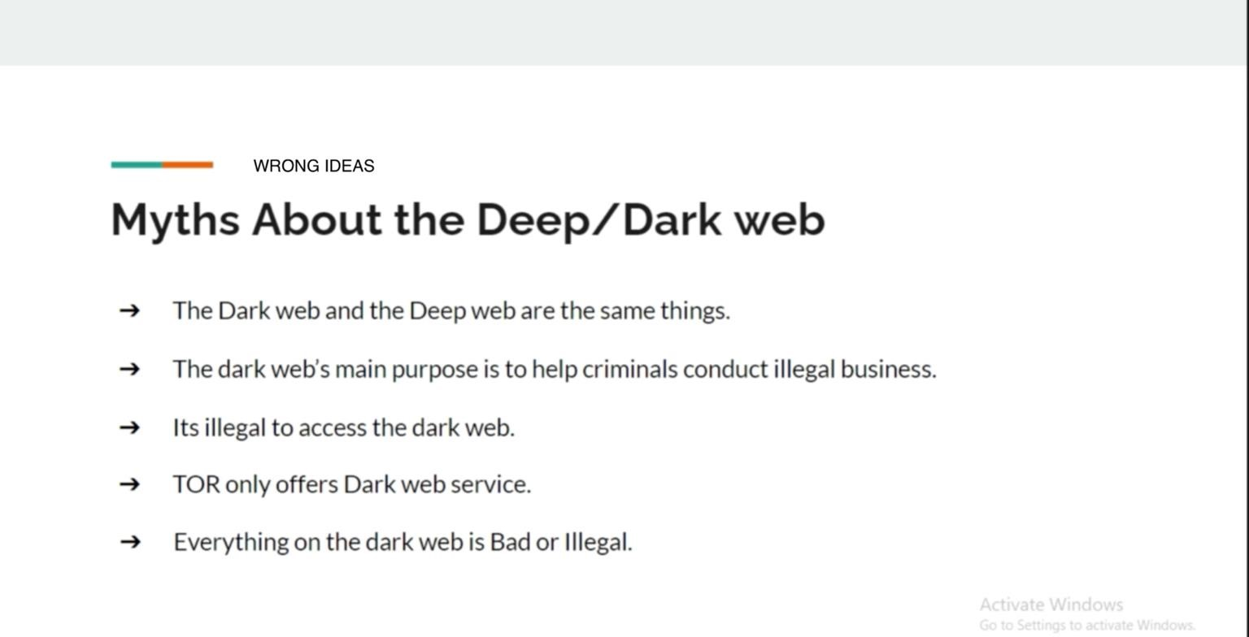

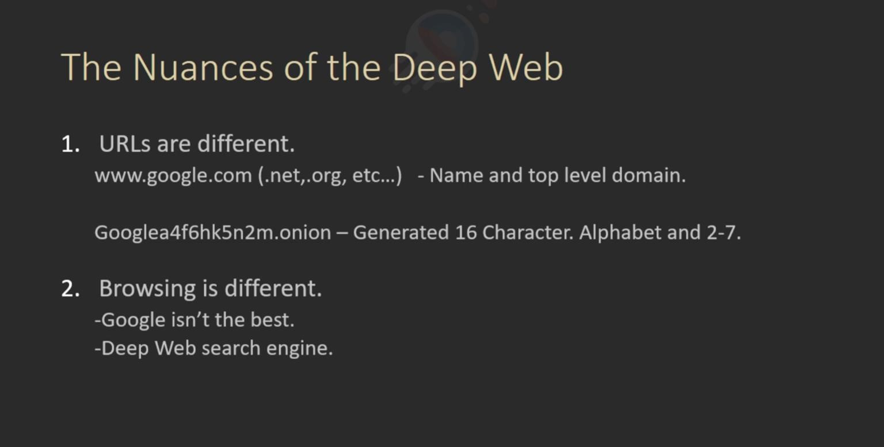

# How the websites addresses looks like

[**http://nr6juudpp4as4gjg.onion/** +](http://nr6juudpp4as4gjg.onion/)– Tor Girls **http://tuu66yxvrnn3of7l.onion/** – UK Guns **http://nr6juudpp4as4gjg.onion/** – Used Tor Guns **http://ybp4oezfhk24hxmb.onion**/ – Hitman Network **http://qizriixqwmeq4p5b.onion/** – Tor Web Developer **http://vfqnd6mieccqyiit.onion/** – UK Passports **http://newpdsuslmzqazvr.onion/** – Peoples Drug Store **http://jv7aqstbyhd5hqki.onion/** – HackBB **http://xfnwyig7olypdq5r.onion/** – USA Citizenship **http://bitmailendavkbec.onion/** – swiss email

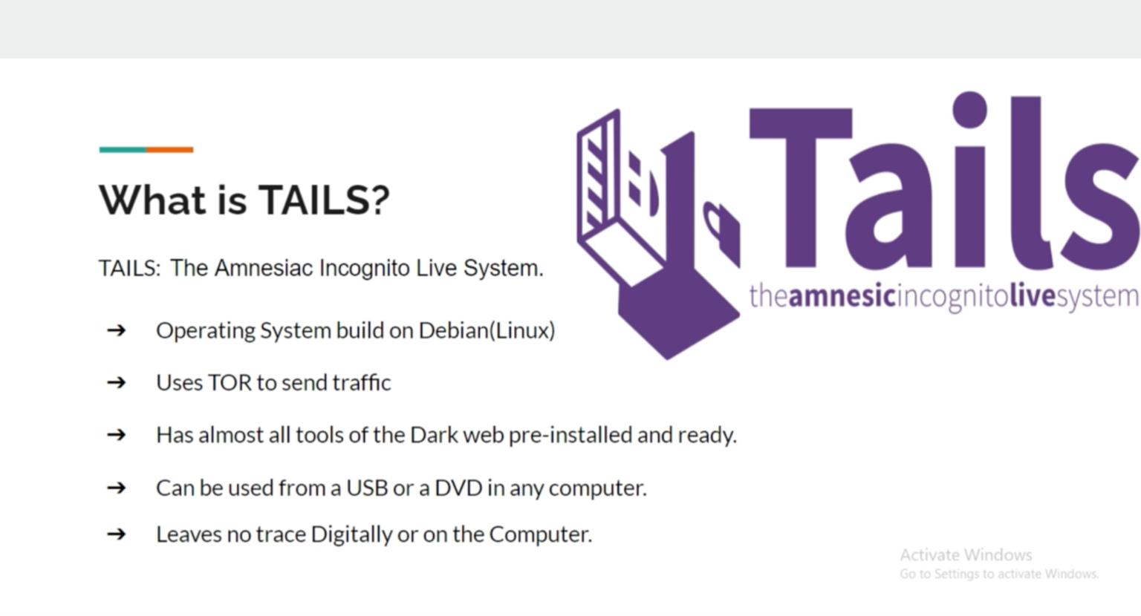

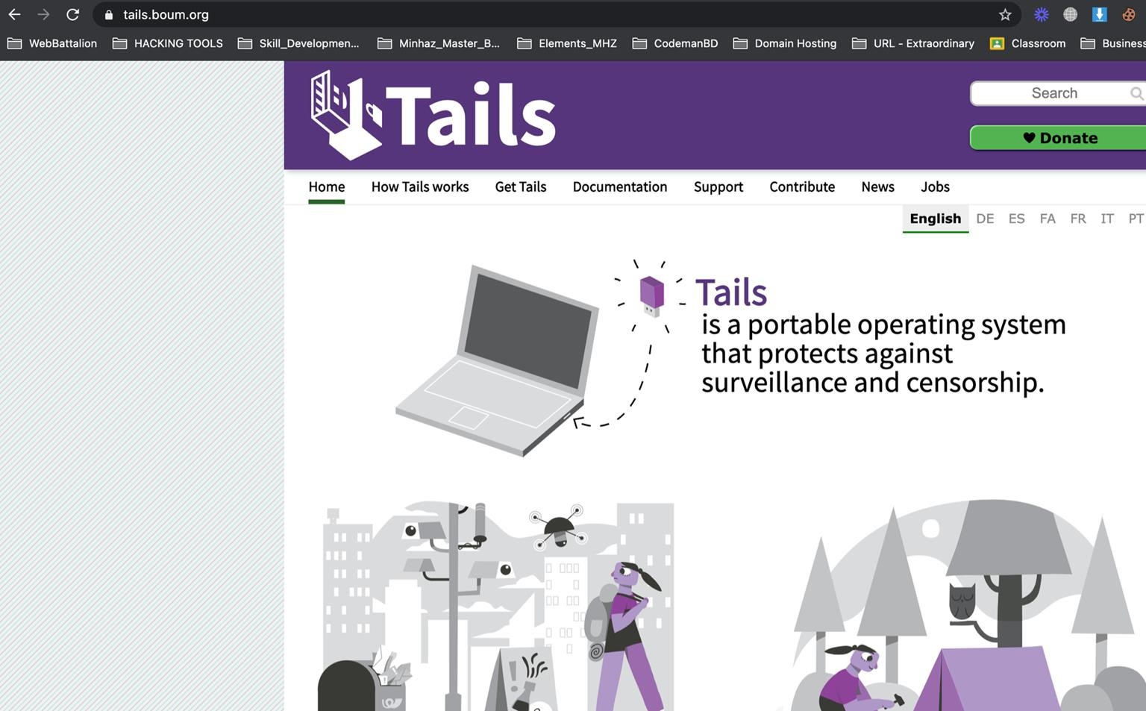

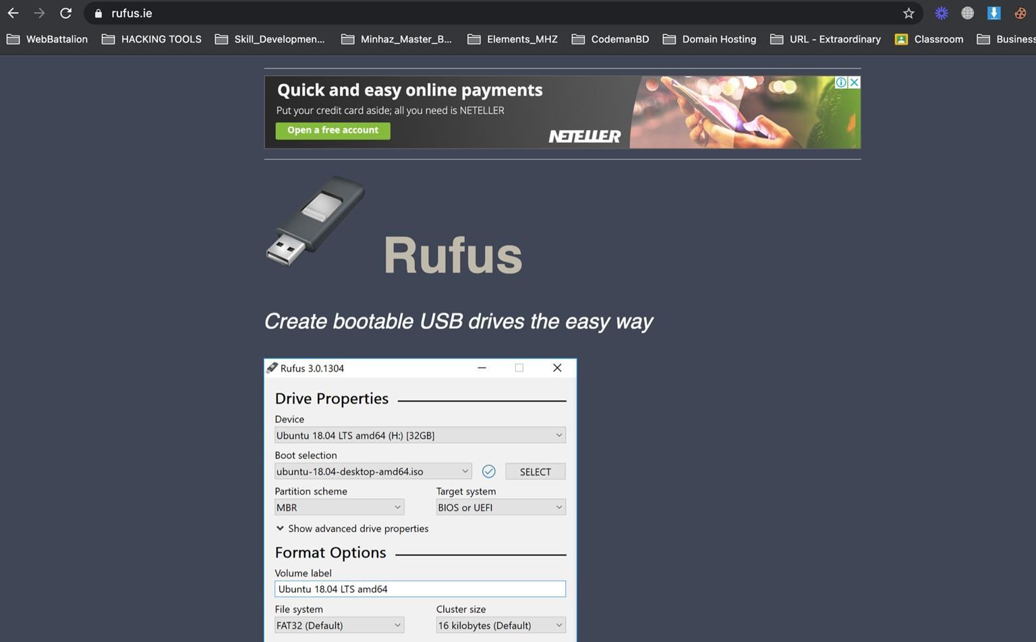

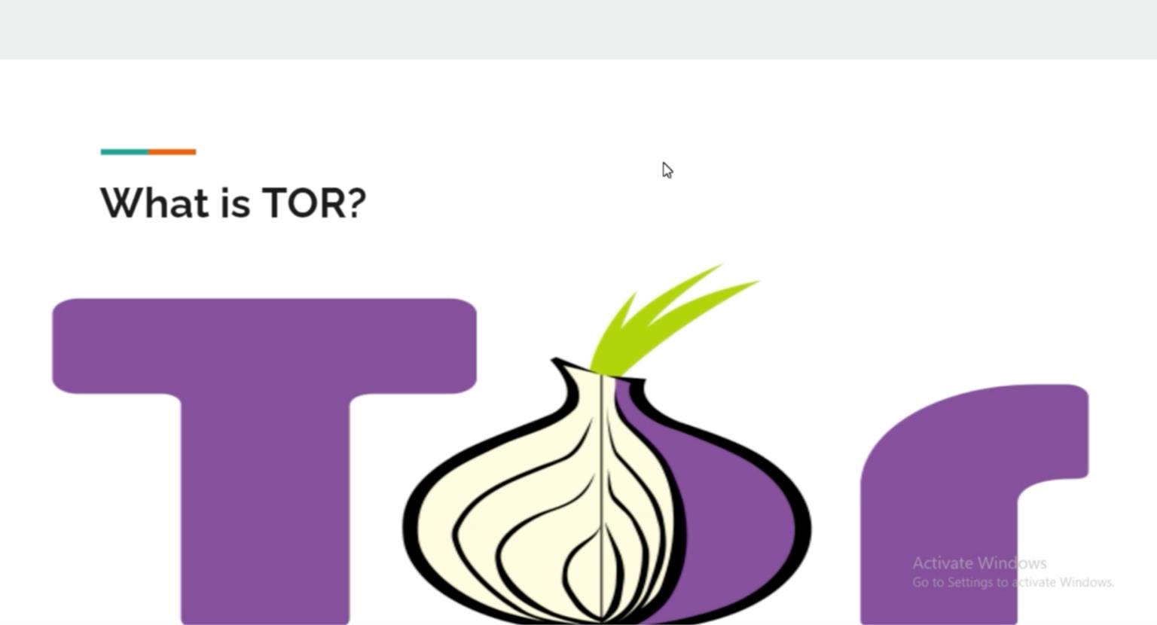

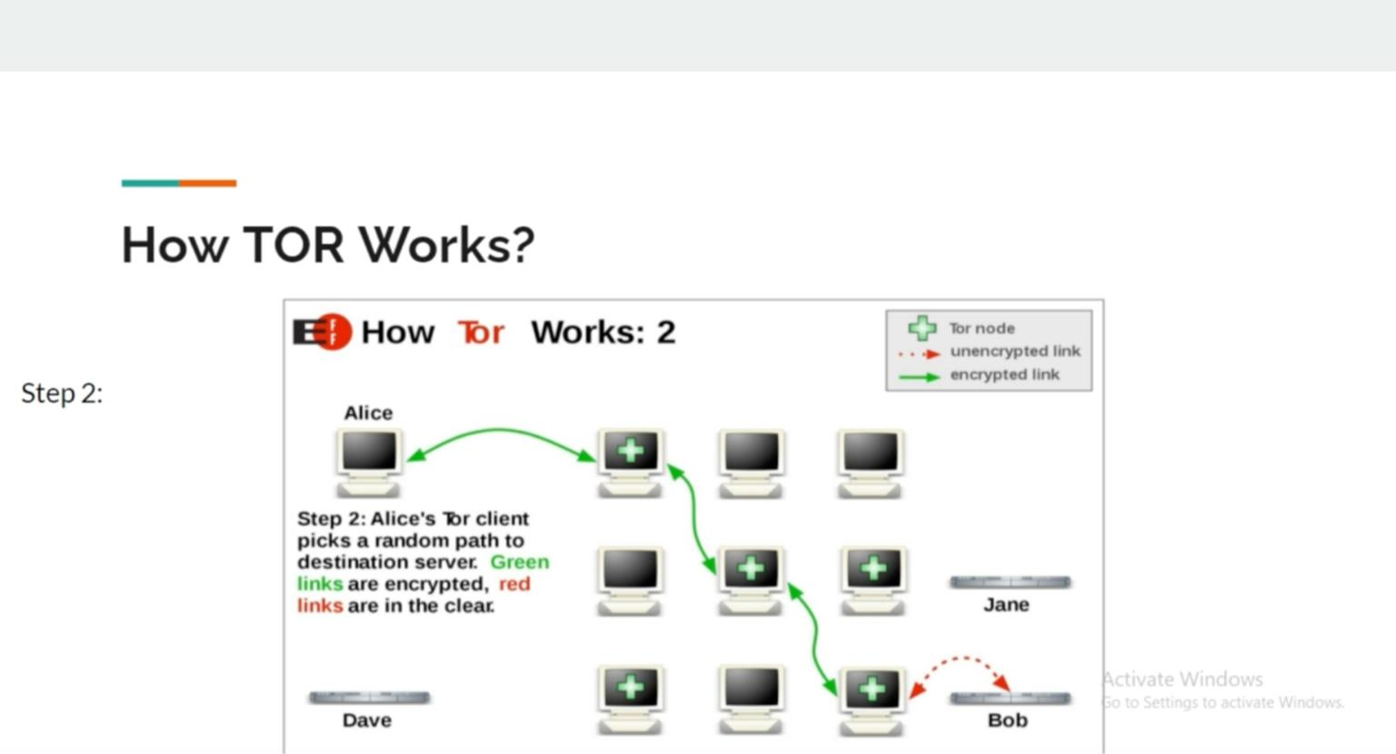

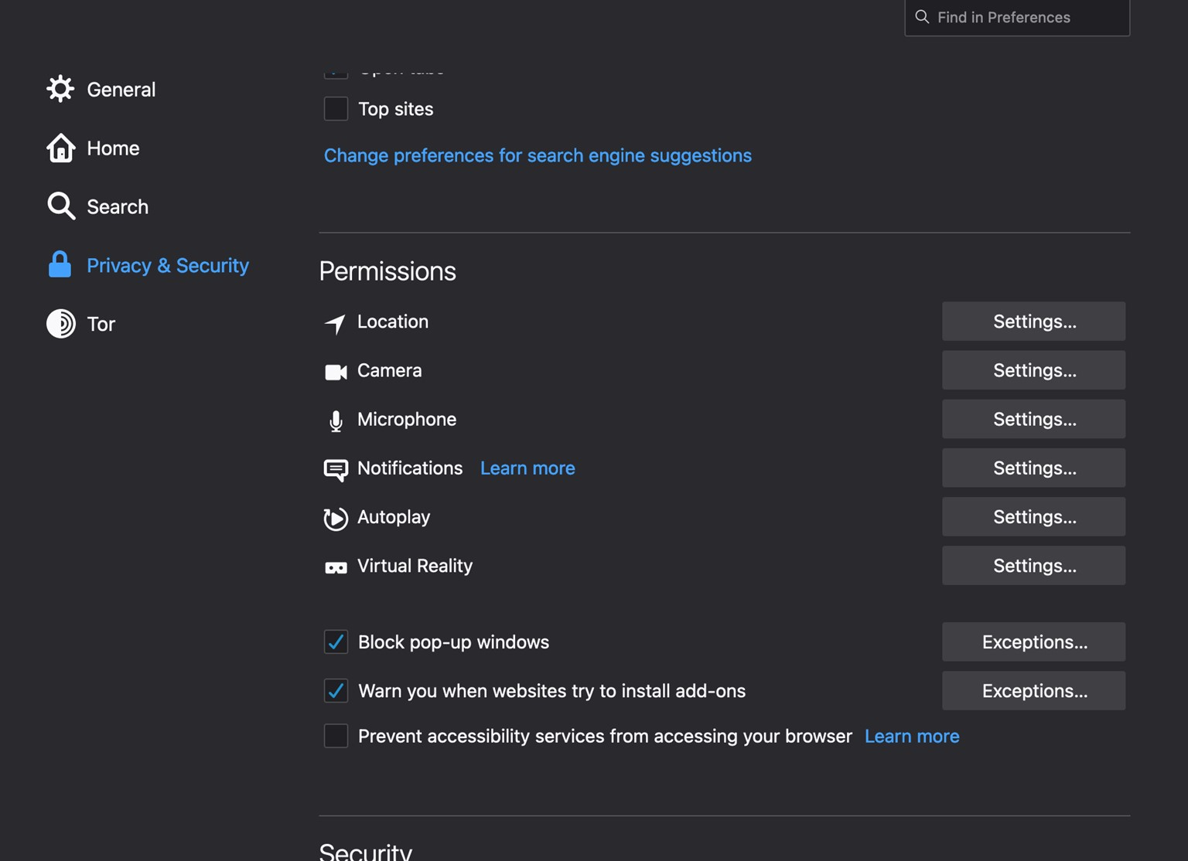

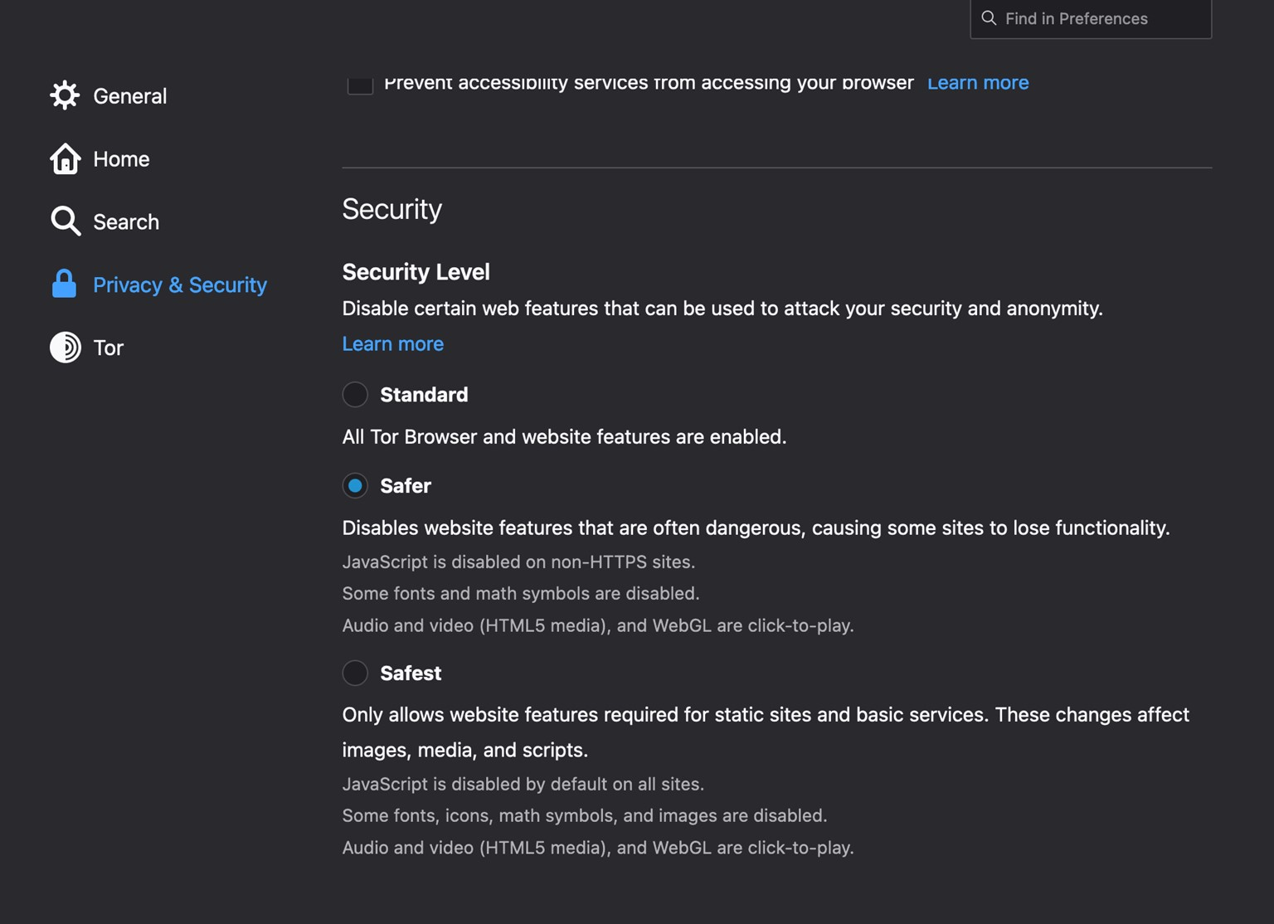

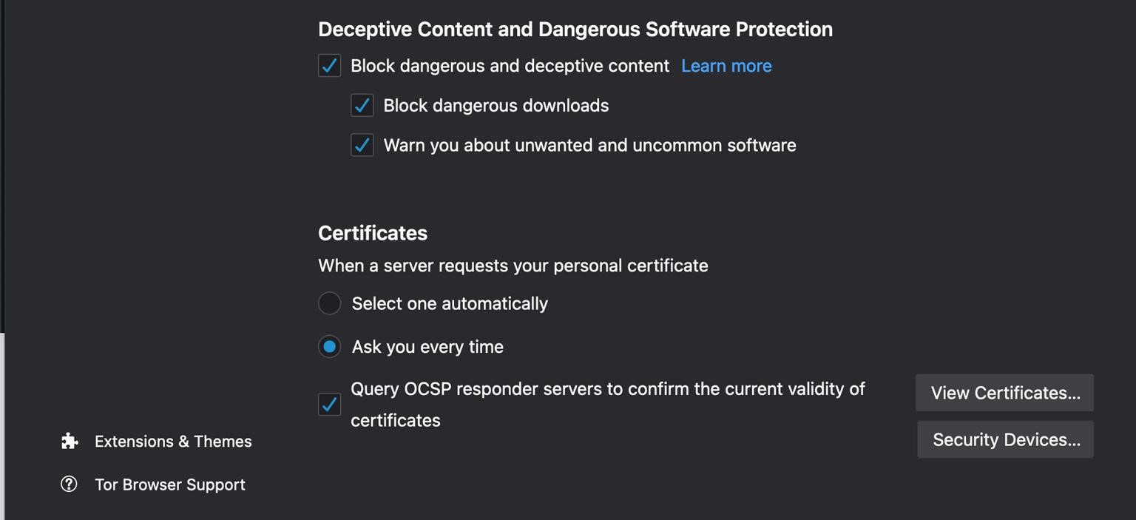

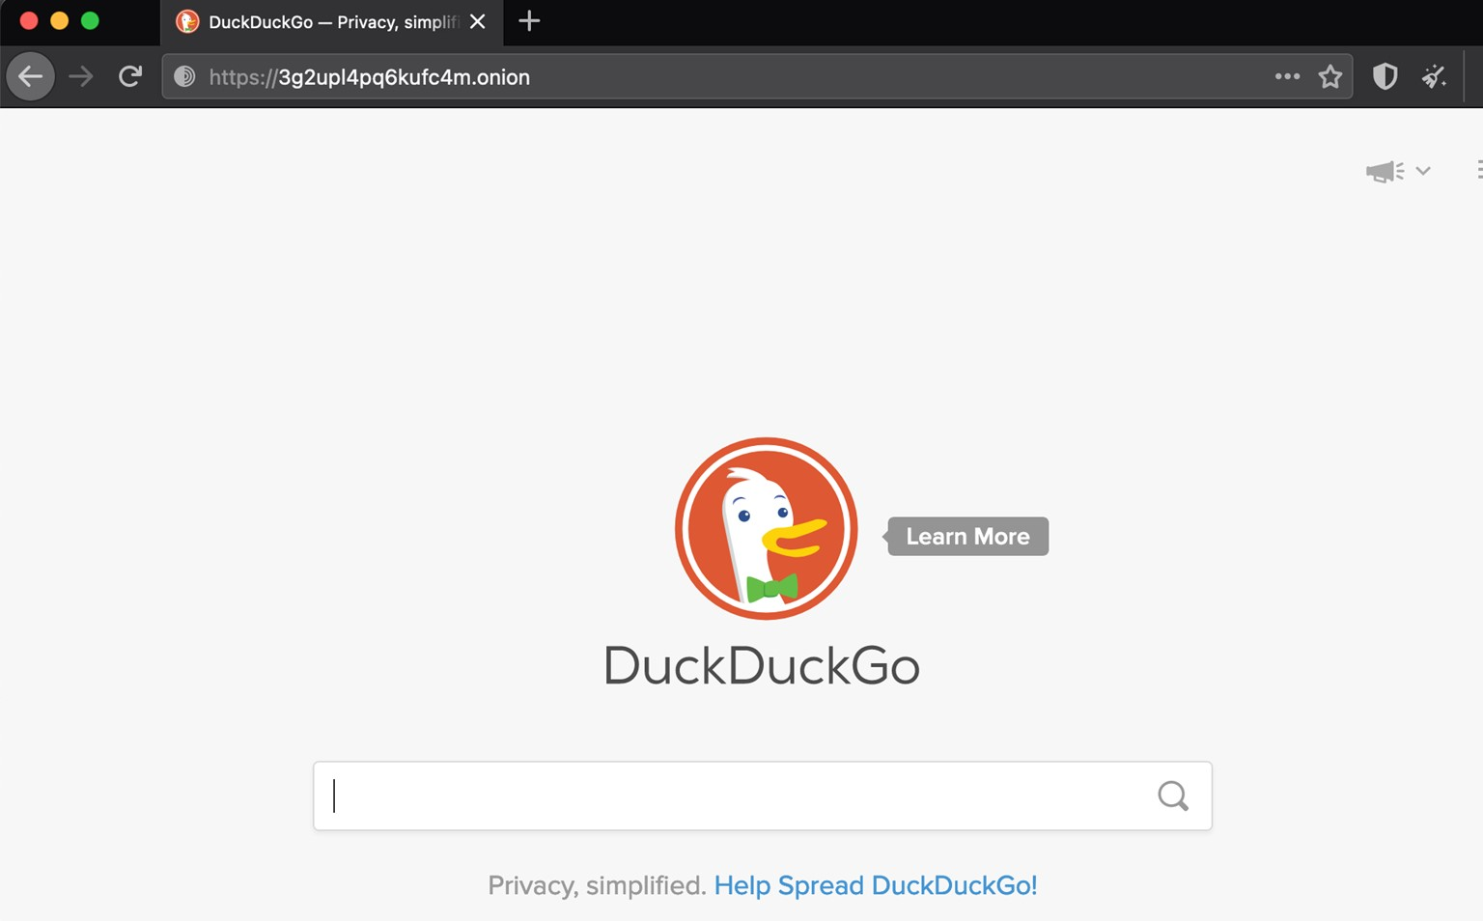

# Some important search engines for dark webs

* **DuckduckGO onion Link: 3g2upl4pq6kufc4m.onion**
* **Excavator dark web engine:**

**2fd6cemt4gmccflhm6imvdfvli3nf7zn6rfrwpsy7uhxrgbypvwf5fad.onion**

* **Grams search engine for darknet:** [**http://grams7enqfy4nieo.onion/**](http://grams7enqfy4nieo.onion/)
* **TORCH FOR FINDING DARK SITES: xmh57jrzrnw6insl.onion**

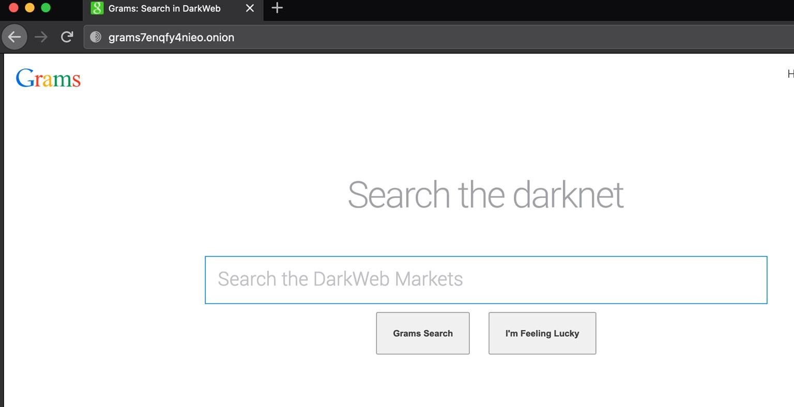

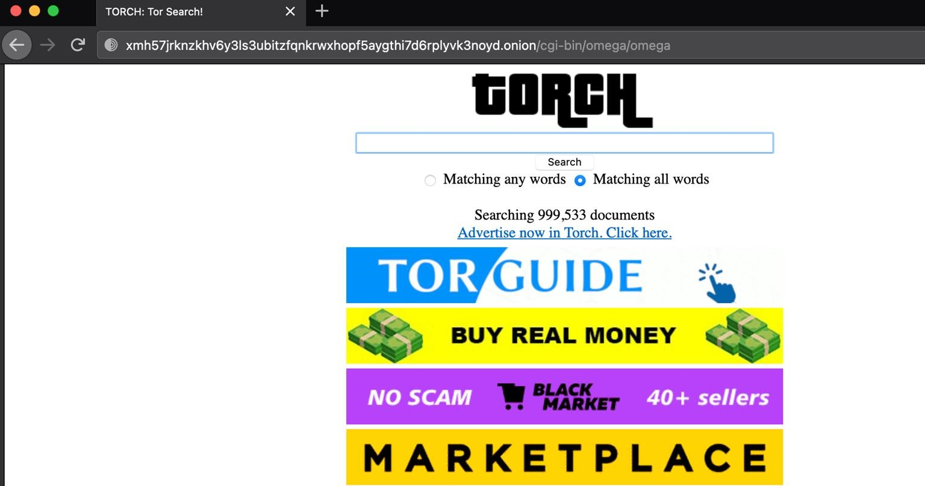

# The Hidden Wikis

* **hidden wiki:**

[**http://zqktlwiuavvvqqt4ybvgvi7tyo4hjl5xgfuvpdf6otjiycgwqbym2qad.onion/wiki/index.php/Main_Page**](http://zqktlwiuavvvqqt4ybvgvi7tyo4hjl5xgfuvpdf6otjiycgwqbym2qad.onion/wiki/index.php/Main_Page)

* **The hidden Wiki(1) Onion Link: • HIDDEN WIKI (Wiki-04):** [**http://hiddenwiki.biz/**](http://hiddenwiki.biz/)
* **WIKI (Wiki-05):** [**http://hiddenwikitor.com/**](http://hiddenwikitor.com/)
* **dark Web Site links(Wiki-06) :** [**https://onion.live/**](https://onion.live/)
* [**http://s4k4ceiapwwgcm3mkb6e4diqecpo7kvdnfr5gg7sph7jjppqkvwwqtyd.onion/**](http://s4k4ceiapwwgcm3mkb6e4diqecpo7kvdnfr5gg7sph7jjppqkvwwqtyd.onion/)  **– OnionLinks v3**
* [**http://6nhmgdpnyoljh5uzr5kwlatx2u3diou4ldeommfxjz3wkhalzgjqxzqd.onion/**](http://6nhmgdpnyoljh5uzr5kwlatx2u3diou4ldeommfxjz3wkhalzgjqxzqd.onion/)  **– The Hidden Wiki**
* [**http://2jwcnprqbugvyi6ok2h2h7u26qc6j5wxm7feh3znlh2qu3h6hjld4kyd.onion/**](http://2jwcnprqbugvyi6ok2h2h7u26qc6j5wxm7feh3znlh2qu3h6hjld4kyd.onion/)  **– Another Hidden Wiki**
* [**http://jgwe5cjqdbyvudjqskaajbfibfewew4pndx52dye7ug3mt3jimmktkid.onion**](http://jgwe5cjqdbyvudjqskaajbfibfewew4pndx52dye7ug3mt3jimmktkid.onion/)  **– Pug’s Ultimate Dark Web Guide**
* [**http://zqktlwiuavvvqqt4ybvgvi7tyo4hjl5xgfuvpdf6otjiycgwqbym2qad.onion/wiki/index.php/Main_Page**](http://zqktlwiuavvvqqt4ybvgvi7tyo4hjl5xgfuvpdf6otjiycgwqbym2qad.onion/wiki/index.php/Main_Page)  **– The original hidden wiki**

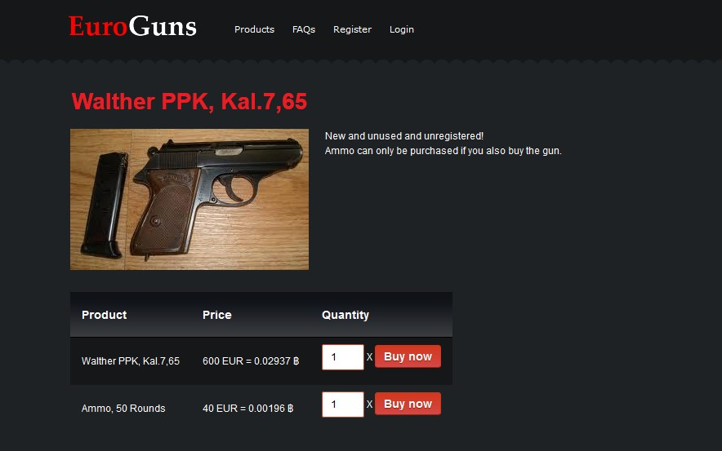

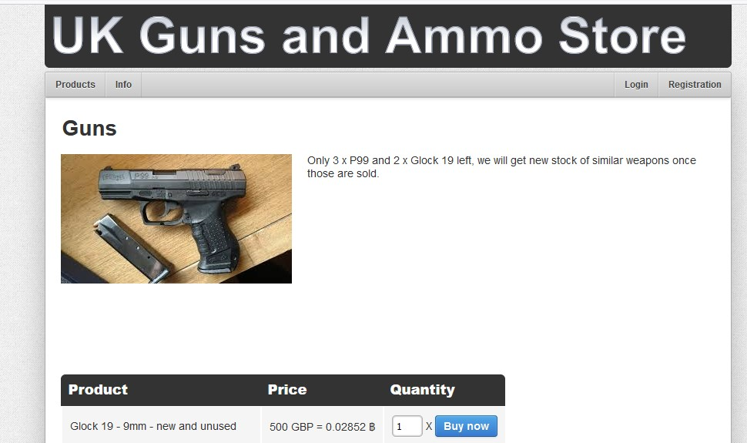

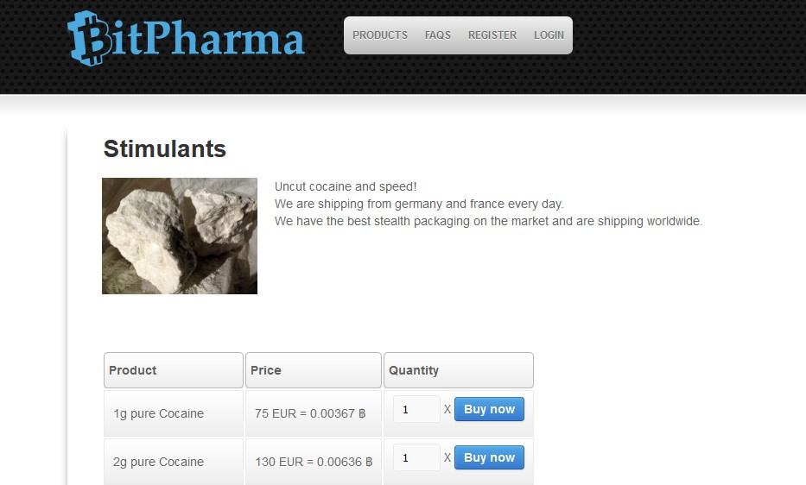

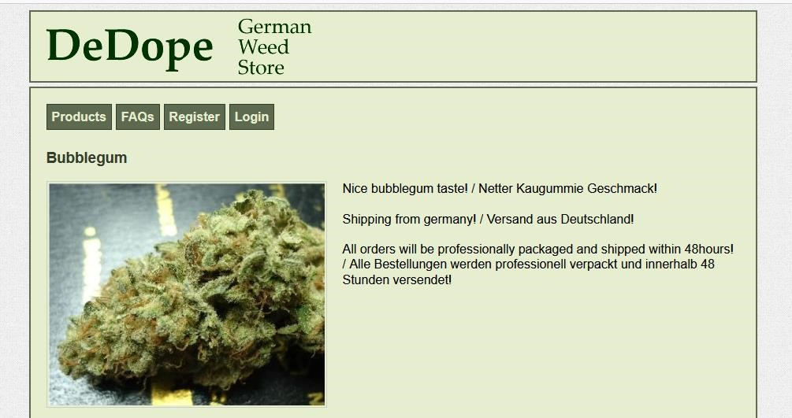

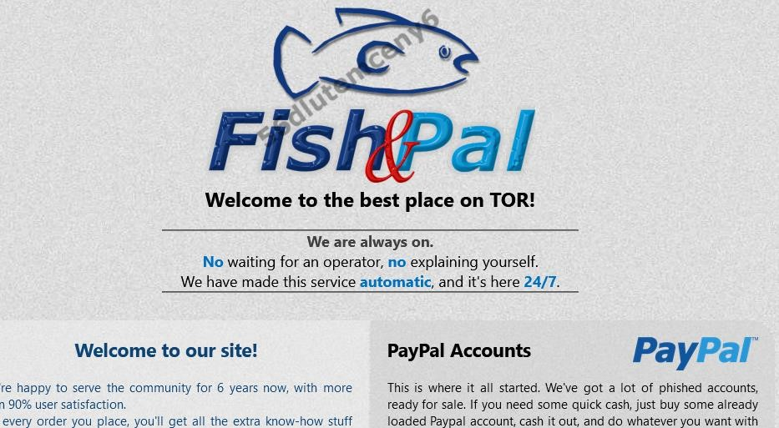

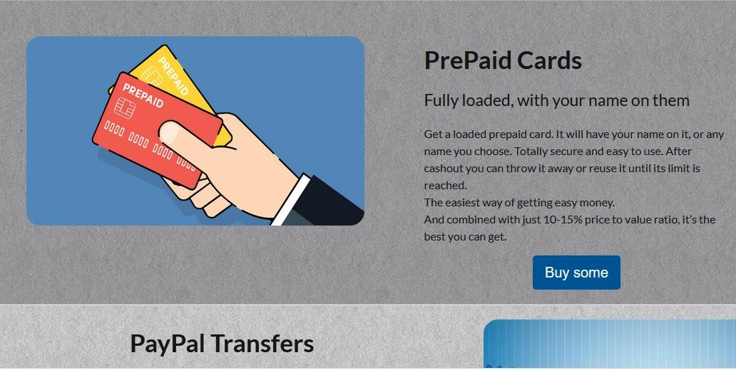

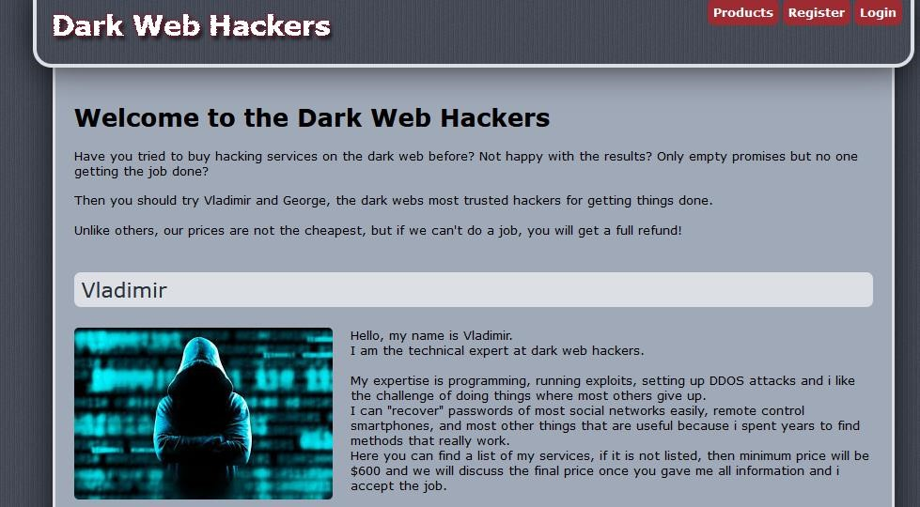

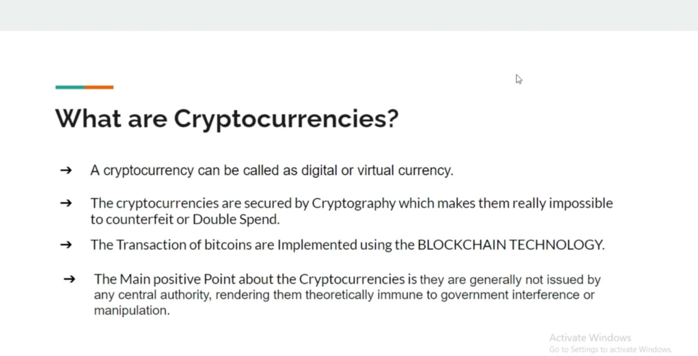

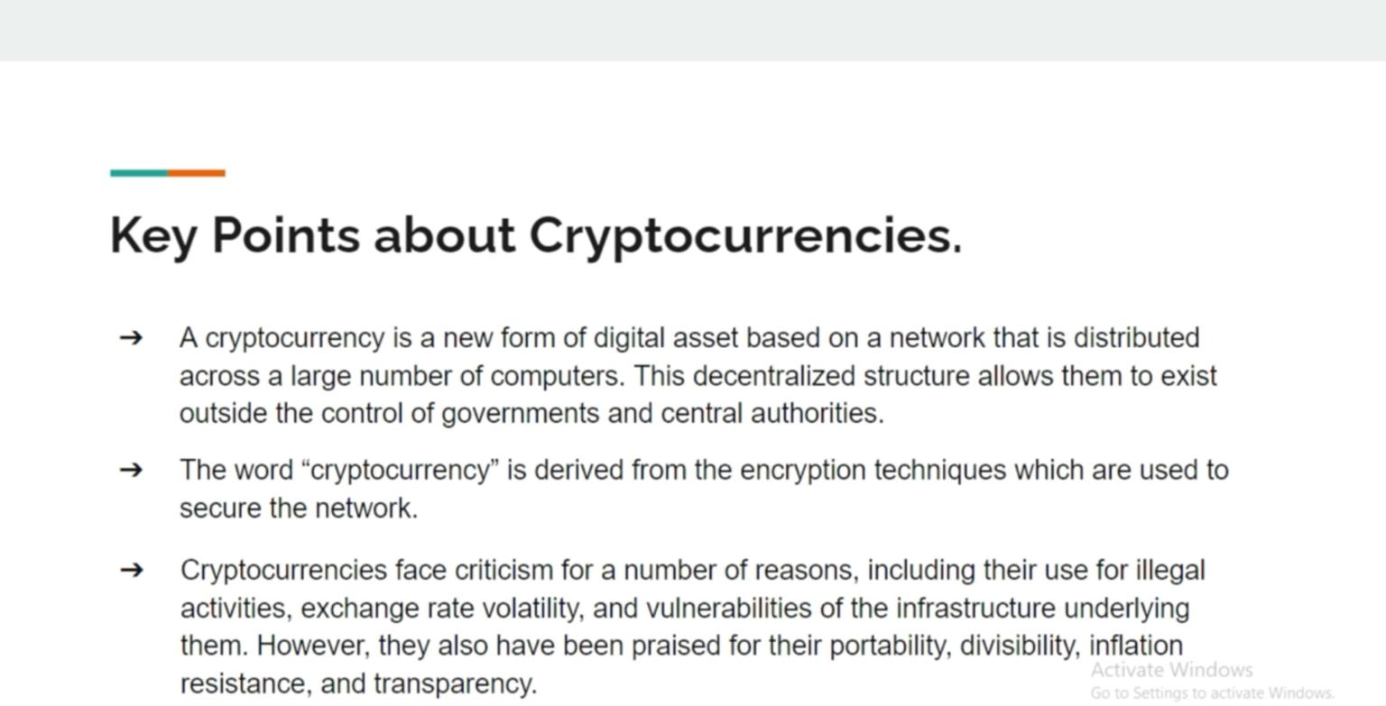

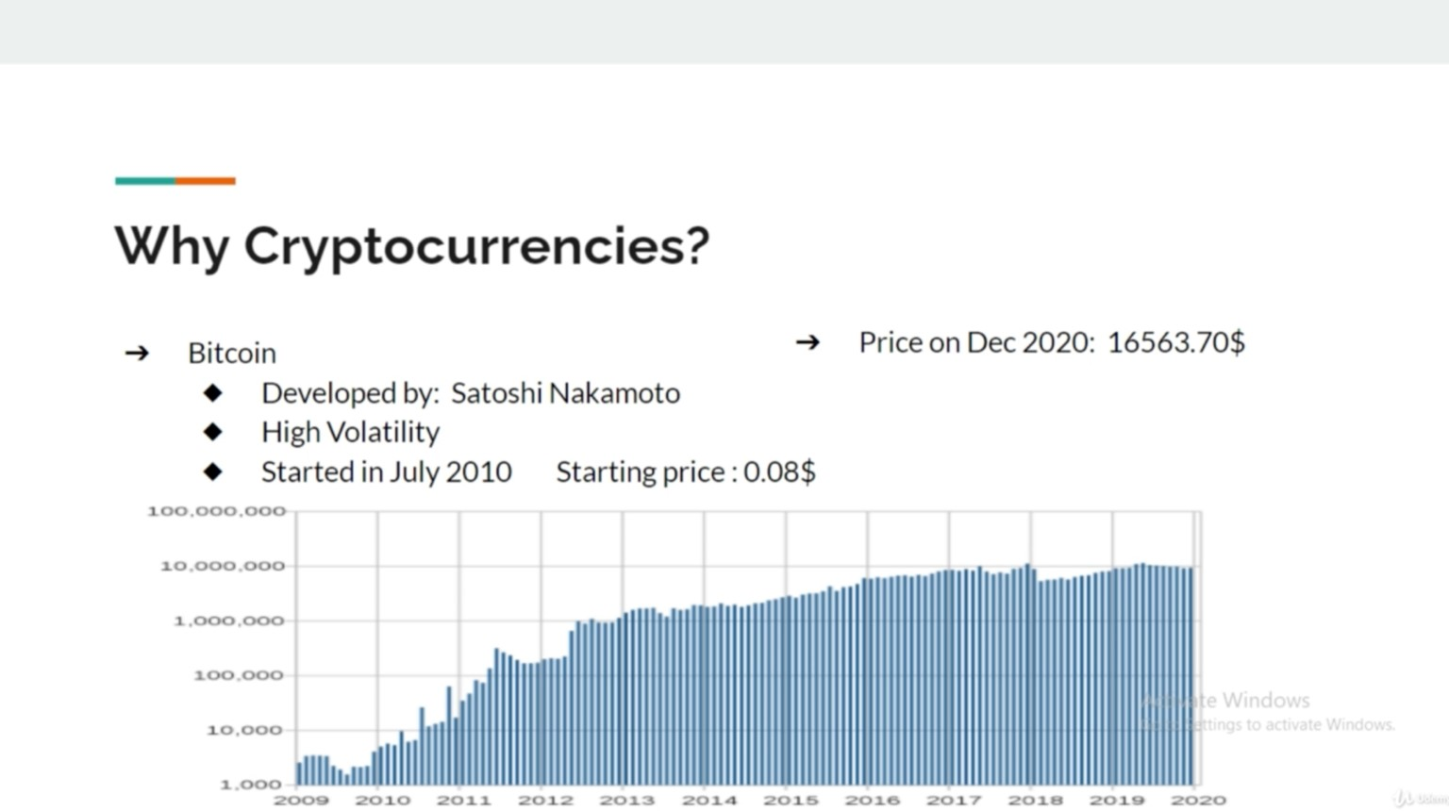

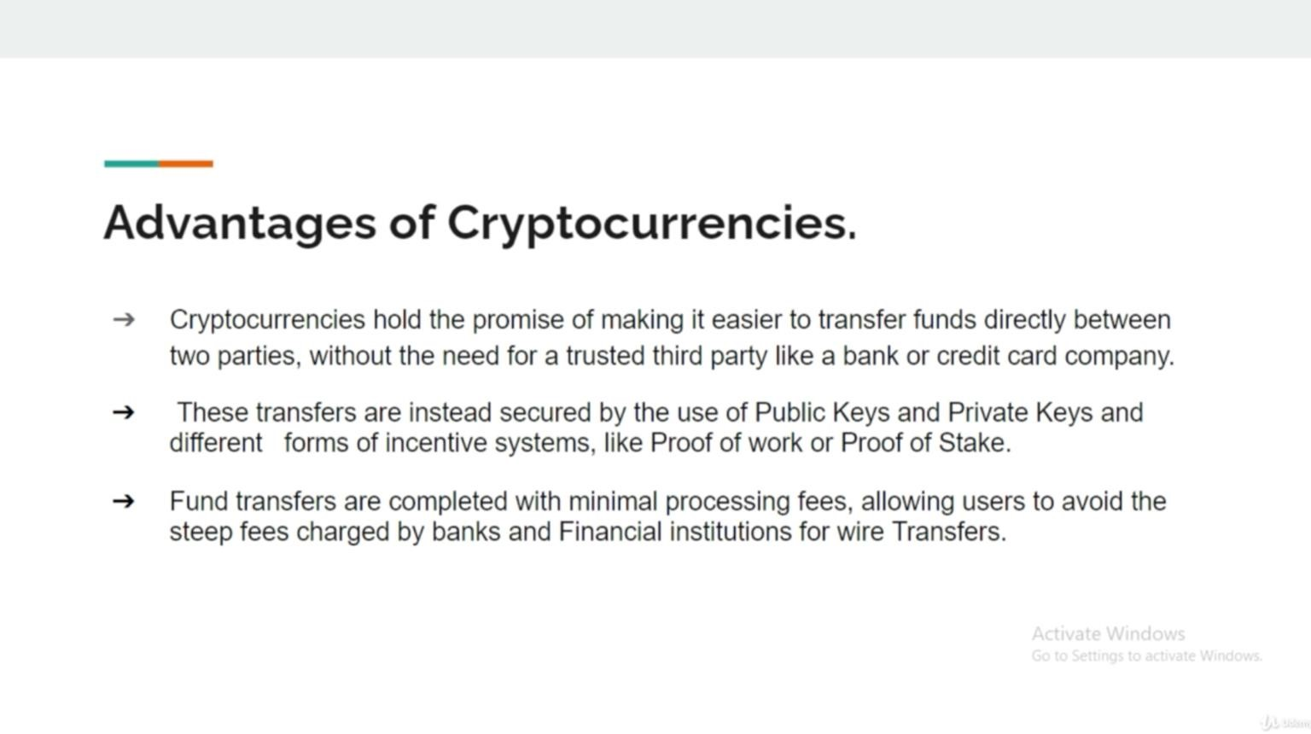

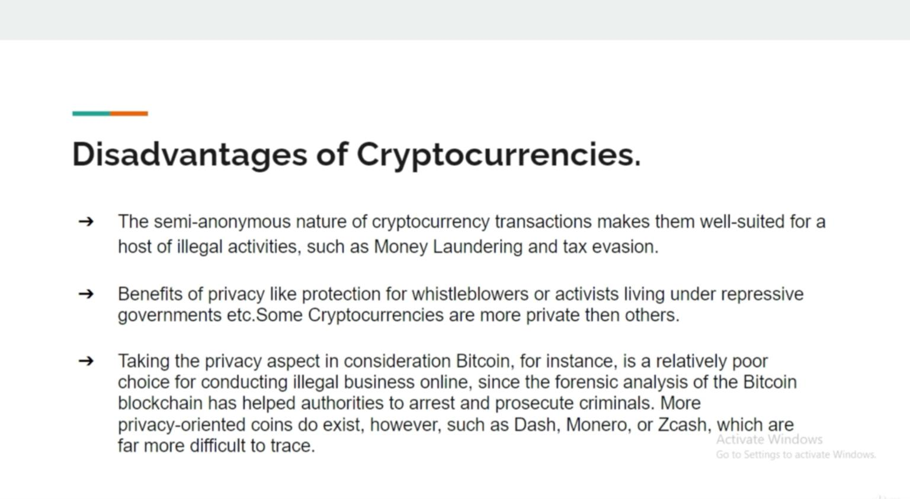

How to get, buy and sell bitcoins ?

1. <https://www.coinbase.com/>
2. <https://www.blockchain.com/>
3. [https://binance.com](https://binance.com/)

# Cryptocurrencies

* **Bitcoin (BTC)**
* **Litecoin (LTC)**
* **Ethereum (ETH)**
* **Zcash (ZEC)**

**See list of cryptocurrencies:** [**https://www.coinbase.com/earn**](https://www.coinbase.com/earn)

